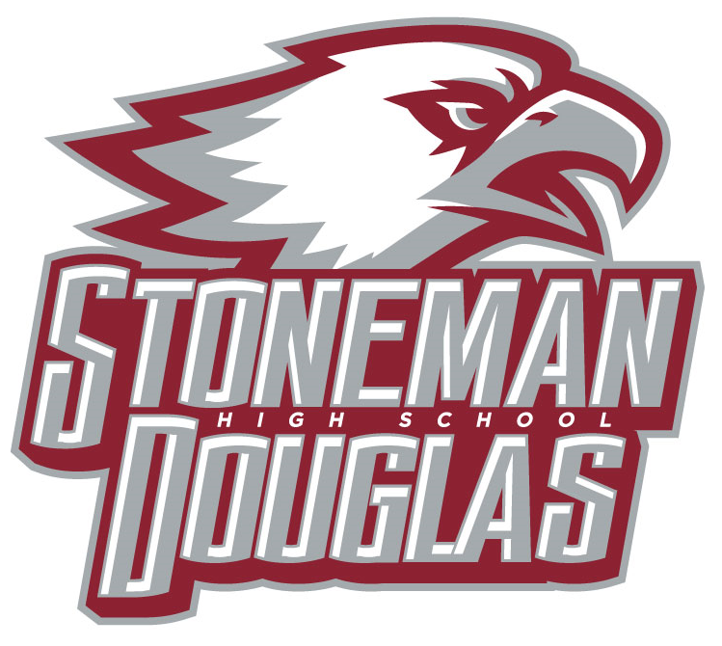

**Meeting Agenda**

**Date:** December 8, 2021

**Time:** 3:15 PM

**Location:** Media Center

1. Welcome/Call to Order/ Review of Agenda
2. Attendance (Roll call)
3. Principal’s Report
   1. SESIR update
4. Revision/Approval of Oct. 2021 SAC minutes
5. SAC Voting:
   1. SAC positions still needed for 2021-2022
      * 1. ESOL
6. Meetings dates for 2021-2022

January 12th (PSD waiver information)

February 9th ( PSD waiver information)

March 9th (PSD continuation waiver vote and Customer survey)

April 13th (SPBP vote, create a nominating committee)

May 11th (Election for 2022-2023 officers)

1. Officers’ Report
   1. School Improvement Plan (SIP):Monitoring
   2. School-wide Positive Behavior Plan (SPBP): Monitoring
   3. Accreditation Process: county is up for accreditation this year
   4. SAC School Accountability Funds: $74,435.20
      * 1. JSTOR- $3825 approved- **($3595.50) spent**
        2. FSA camps- (**436.02) spent**
2. Special orders/unfinished business from previous meeting
3. New business
   * + 1. SMART bond- Milmed
       2. Waiver- Koltunova
4. Announcements/Reminder: Professional Study Days (PSD Thursdays students dismissed at 11:40 AM): 1/6, 2/3, 3/3, 4/7
5. Next meeting: January 12th at 3:15 PM
6. Adjournment